Automation of RSO Binders



TEAM MEMBERS

Ruchi Goyal

Reema D'Mello

Shashwath Mehra

Raghuram Parthasarathy

Harish Gunasekaran

Table of Contents

1. BUSINESS CASE 4

1.1 Executive Summary 4

1.2 Case Background 4

1.2.1 Problem Statement 4

1.2.2 Anticipated Outcomes 4

1.3 Business Case Analysis Team 4

1.4 Project Overview 5

1.4.1 Project Description 5

1.4.2 Goals and Objectives 5

1.4.3 Organizational Impact 6

1.4.4 Assumptions 6

1.4.5 Constraints 6

1.4.6 Project Milestones 7

1.5 Cost Benefit Analysis 8

1.6 Alternative Analysis 8

2. REQUIREMENT DOCUMENTS 9

2.1 Introduction 9

2.2 Business Requirements 9

2.3 Functional Requirements 10

2.4 Non Functional Requirements 11

3. DIAGRAMS AND PROCESS FLOWS 12

3.1 Use Case Diagram 12

3.2 Activity Diagram 13

3.3 Process Flow Diagram 16

3.4 User Personas 18

4. Use Cases 18

5. User Interface Displays 22

5.1. Login Screen 22

5.2 Proctor Home Page 23

5.3 Swipe Resident 25

5.4 Valid Guest 26

5.5 Banned Guest 26

5.6 Live Chat with Supervisor 27

5.7 Side Panel for Proctor 28

5.8 Supervisor Home Page 29

5.9 Supervisor Banned List alerts 30

5.10 Medical Alerts Supervisor 31

5.11 Supervisor Side Panel 32

5.12 NUPD Home Page 33

5.13 NUPD Lost Items 34

5.14 NUPD Medical Alerts 35

5.15 NUPD Non Medical Alerts 36

5.16 NUPD Banned List Alerts 37

# 1. BUSINESS CASE

## 1.1 Executive Summary

The business case outlines how the web based application will improve efficiency, enhance guest experience and ensure safety of the students residing in northeastern residential buildings. The current process includes proctors manually entering the records of all the guests by checking their identification and looking them up on the banned list. This process is very time consuming and there are long queues during rush hours or special events. There is no database which contains the records of all the guests, but the information is scattered in multiple sheets of paper which leads to inconvenience when retrieving data later on. The proposed system will automate this process and provide for better database management, reduce overhead on proctors, ensure 100% safety by eliminating manual errors, and contribute to the university’s initiative of safe student environment and global warming by eliminating the usage of paper.

## 1.2 Case Background

### 1.2.1 Problem Statement

Currently, RSO Proctors are recording guest’s entries manually on a paper binder. And these residential dorms usually have large number of guests on a daily basis. There is a long queue during rush hours and RSO Proctors have to manually sign in everyone by checking their valid ID card and simultaneously cross check the entries in the banned lists, provided by RSO. This increases the probability of tail gating and blow-by scenarios.

### 1.2.2 Anticipated Outcomes

Moving to a centralized web-based platform will enable RSO to maintain the records of the guests in a seamless and organized manner. It will reduce the overhead on the proctors during the rush hours and eliminate any chances of manual error. Banned users will be automatically detected by the system and a log of this will be maintained for future reference. This application will also bring in additional features like generating monthly reports based on various metrics, tracking the traffic across various residential buildings and easy inspection if cases of security breach or similar are encountered.

## 1.3 Business Case Analysis Team

The following individuals comprise the business case analysis team. They are responsible for the analysis and creation of the Automation of RSO Binder.

|  |  |  |
| --- | --- | --- |
| Role | Description | Name/Title |
| RSO Supervisors/Proctors | Improves guests and student’s satisfaction. | Time saving of the student’s, guests, eliminate manual error |
| Executive Sponsor | Provide executive support for the project | RSO |
| NUPD | Provides all the security support and details. Will be more efficient for any case investigation. | Northeastern University Police Department. |
| Software Support | Provides all software support for the project | Developers |

## 1.4 Project Overview

The Automation of RSO Binder project will enhance the guest experience and ensure resident safety. This section consists of project goals and objectives, project constraints and assumption, and major milestones. Once the project is approved and moves forward, each of the components will be expanded to include a greater level of detail in working towards the project plan.

### 1.4.1 Project Description

The automation of the RSO binder will replace the existing sign in sheets that are being used for guest entry thereby eliminating manual errors. The system will have a scanner that is connected to a centralized database and it keeps track of all the entries made in the resident halls. The new system will also verify a guest's photo ID with the banned list and alert the proctors from allowing access to students and their guests.

Once approved, the application will replace the old system in a phased implementation approach and will be implemented once the new system is fully operational. The application will improve the efficiency of guest entry and assist the RSO administrative team in managing the reports.

### 1.4.2 Goals and Objectives

The project directly supports all the goals and objectives of RSO department. The following table lists the goals and describes the way it will be supported:

| Business Goal/Objective | Description |
| --- | --- |
| Ensure Residents safety | The new application will prevent people in the banned list from entering the resident hall and reduces manual errors. |
| Reduce guest wait time | The guests need not wait for a long time during rush hours to enter the resident halls |
| Improve staff efficiency | The application has a quick response time that improves the efficiency of the staffs by reducing the time taken for sign in |
| Proper management of database | All the guest and resident records are stored in a database and can be retrieved easily whenever needed |

### 1.4.3 Organizational Impact

The Automated Binder will impact the current manual binder and entries in many ways. The benefits will impact organization, processes, and resources in the following way:

* The manual entry labor will be taken over by the system which is automated for signing in guests, which will be more efficient and less time consuming.
* Northeastern University Police Department can investigate the case more efficiently.
* This project is eco-friendly, which will help and support the awareness of eco-friendly projects in Northeastern University.
* The guests’ entries will be persisted and stored in a database, that can be utilized for further business intelligence and analytics to improve the efficacy.

### 1.4.4 Assumptions

The following assumptions apply to the RSO Binder Automation Project. As project planning begins and more assumptions are identified, they will be added accordingly.

* All staff and employees will be trained accordingly to use the new system for an efficient data entry
* Funding is available for purchasing hardware/software for the new system
* Northeastern University administrators and NUPD will provide necessary support for successful project completion
* The new system will undergo scheduled maintenance and gets updated then and there

### 1.4.5 Constraints

The following constraints apply to the Automation of RSO Binder Project. As project planning begins and more constraints are identified, they will be added accordingly.

* All the identification cards provided by the guests should have a barcode in order to scan and populate their details efficiently into the database
* The proctors should be prepared to enter the student/guest details in a paper manually in case the new system shut downs suddenly
* Since the implementation will be done internally and not by the product developers or vendors, there will be limited support from the hardware/software providers.

### 1.4.6 Project Milestones

The following are the major project milestones identified at this time. As the project planning moves forward and the schedule is developed, the milestones and their target completion dates will be modified, adjusted, and finalized as necessary to establish the baseline schedule.

| **Milestones/Deliverables** | **Target Date** |
| --- | --- |
| Project Plan Review and Completion | 03/01/2017 |
| Project Kickoff | 03/10/2017 |
| Phase I complete - Arrange meetings with Architect, RSO Supervisors, NUPD | 03/15/2017 |
| Phase II Complete - Build Project Application | 04/15/2017 |
| Phase III Complete - Test the application in one of the resident halls | 05/30/2017 |
| Phase IV Complete - Train proctors after the tested application is successful | 06/25/2017 |
| Phase V Complete – Deploy the new system in all the residence halls | 07/30/2017 |
| Closeout/Project Completion | 08/10/2017 |

## 1.5 Cost Benefit Analysis

The following table captures the cost and savings actions associated with the WP Project, descriptions of these actions, and the costs or savings associated with them through the first year. At the bottom of the chart is the net savings for the first year of the project.

| **Action** | **Action Type** | **Description** | **First year costs (- indicates anticipated savings)** |
| --- | --- | --- | --- |
| Purchase Web-based product software, licenses and scanners. | Cost | Initial investment for the Project | $18,000.00 |
| Software installation and training | Cost | Cost for IT group to install new software and for the training group to train all employees | $6000.00 |
| Upgrades and maintenance cost | Cost | Cost for maintaining and upgradation of the software and hardware yearly. | 3000.00 |
| No longer use of papers | Savings | No use of paper results in approximately $2000 savings per year. | -$2000.00 |
| Format of Sign in sheets will no longer be printed | Savings | Printing cost will be saved. | -$1000.00 |
|  |  |  |  |

Based on the cost benefit analysis above we see that by authorizing the Project, and initially investing a small amount in the project, better security and safety can be provided to the students which is the main objective of RSO.

## 1.6 Alternative Analysis

The following alternative options have been considered to address the business problem. These alternatives were not selected for a number of reasons which are also explained below.

| **No Project (Status Quo)** | **Reasons for Not Selecting Alternative** |
| --- | --- |
| Stay with the current system | * Continued occurrence of a high number of blow by scenarios * No centralized data and proper database management * Huge queues during rush hours * No proper maintenance of binders and records * Prone to manual errors * Non-eco-friendly. |

# 2. REQUIREMENT DOCUMENTS

## 2.1 Introduction

## 2.2 Business Requirements

Business-level requirements are written from the sponsor’s perspective. The business requirements identify the reason why the project is being done or what business objective it supports, as well as the benefits to the business. Business requirements are typically documented early in the project life cycle or the planning phase of the project, and are frequently documented in the project management deliverables.

|  |  |
| --- | --- |
| ID | Business Requirement Statement |
| B1 | The system shall provide ability to validate the identification of students as well as guests |
| B2 | The system shall provide ability to check the guests against banned list |
| B3 | The solution shall provide secure data storage for all guest’s information, student information and their visit histories. |
| B4 | The solution shall provide capability to alert NUPD in case of medical and non-medical emergencies. |
| B5 | The system shall provide capability of adding up to 5 guests per student. |

## 2.3 Functional Requirements

Functional requirements are written from the system’s (features or functions) perspective. What must the system do to support the user role? Information referenced in the functional requirements is described in the “Common Information” section below.

They are the Inputs and Outputs of the business process. They describe “what” the user expects to obtain or needs from the system. These statements support the business requirements. The Use Case form may also be used as a supplement to the User Requirements section.

| ID | User and Functional Requirement Statements |
| --- | --- |
| User Role | Proctor |
| Goal U1 | Login |
| U1.1 | The proctor should login to the system |
| U1.1F1 | Proctor Swipes the ID card of the resident |
| U1.2 | System validation |
| U1.2F1 | System will validate if the student resides in the building |
| U1.2F2 | System notifies the proctor with a green light and a pop up with the details if the student is a valid resident. Student is given access to enter the building by proctor |
| U1.2F3 | System notifies the proctor with a red light and a pop up with the details if the student is not a resident. Nonresident is not given access to enter by proctor |
| Goal U2 | Monitor Alerts |
| U2.1 | The proctor will send the alerts. |
| U2.1F1 | The proctor will send the alerts to NUPD and supervisors in case there is any medical emergency |
| U2.1F2 | The proctor will send the alerts to NUPD and supervisors in case there is any non- medical emergency |
| U2.1F3 | The proctor will send the alerts to NUPD and supervisors in case a person in the banned list tries to enter |
| User Role | NUPD Staff/Supervisors |
| Goal U1 | Login |
| U1.1 | The supervisors and NUPD staff should be logged in |
| U1.1F1 | They should be logged in all the time to monitor the system and processes. |
| Goal U2 | Access Database |
| U2.1F1 | The supervisor and NUPD can only access the database |
| Goal U3 | Monitor Alerts |
| U3.1F1 | To monitor the Medical alerts and take necessary actions |
| U3.1F2 | Monitor the Non- Medical alerts and take necessary actions |
| U3.2F3 | Monitor Banned List alerts and take necessary actions |

## 2.4 Non Functional Requirements

Nonfunctional requirements focus on the qualities that must be applied to design and implement the system. These are specific standards and attributes in support of the other requirements.

| ID | Non-Functional Requirement Statements |
| --- | --- |
| OPERATION Requirements: | |
| Access Security | |
| N-ACS1 | The system shall allow only authorized user to log in. |
| N-ACS2 | The system shall allow only the authorized NUPD officials and supervisors to access the database information |
| Availability | |
| N-AVL1 | The system shall be available 24* 7 throughout the year |
|  |  |
| Efficiency | |
| N-EFC1 | The system shall notify the alerts to the NUPD, supervisors and proctors without any delay. |
| N-EFC3 | The system shall support in rush hours and should support for the ever increasing number of the residents |
| Integrity | |
| N-INT1 | The system shall maintain and protect all the personal information about the residents and guests |
| Reliability | |
| N-REL1 | The system shall be able to carry forward the approved requests to for the next shuttle and notify the students about it. |
| Survivability | |
| N-SRV1 | The system shall identify the internet connection issues to work efficiently and accurately. |
| N-SRV2 | The system shall notify the proctor/supervisor about the internet connection issues, if any. |
| N-SRV3 | The technical support shall be available as and when needed. |
| Usability | |
| N-USE1 | The system shall be user friendly and responsive |
| TRANSITION Requirements: | |
| Interoperability | |
| N-IOP1 | The system shall be accessible from the mobile devices as well as from the web browsers. |
| N-IOP2 | The system shall be able to work with any web browser. (IE > 8.0; Mozilla Firefox; Google Chrome) |

# 3. DIAGRAMS AND PROCESS FLOWS

## 3.1 Use Case Diagram

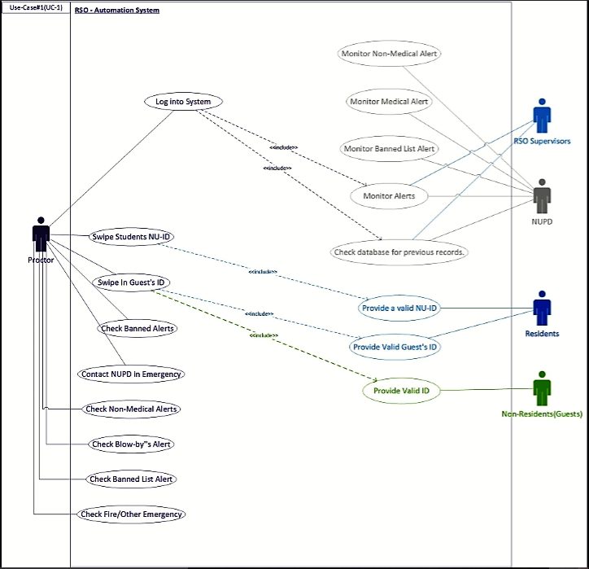

## 3.2 Activity Diagram

## 

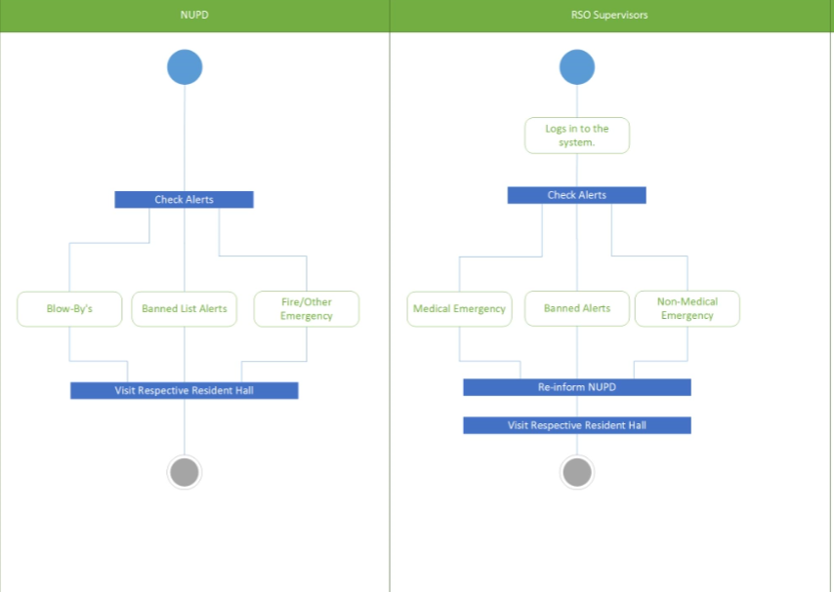

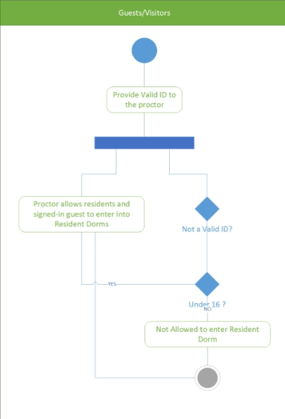

## 3.3 Process Flow Diagram

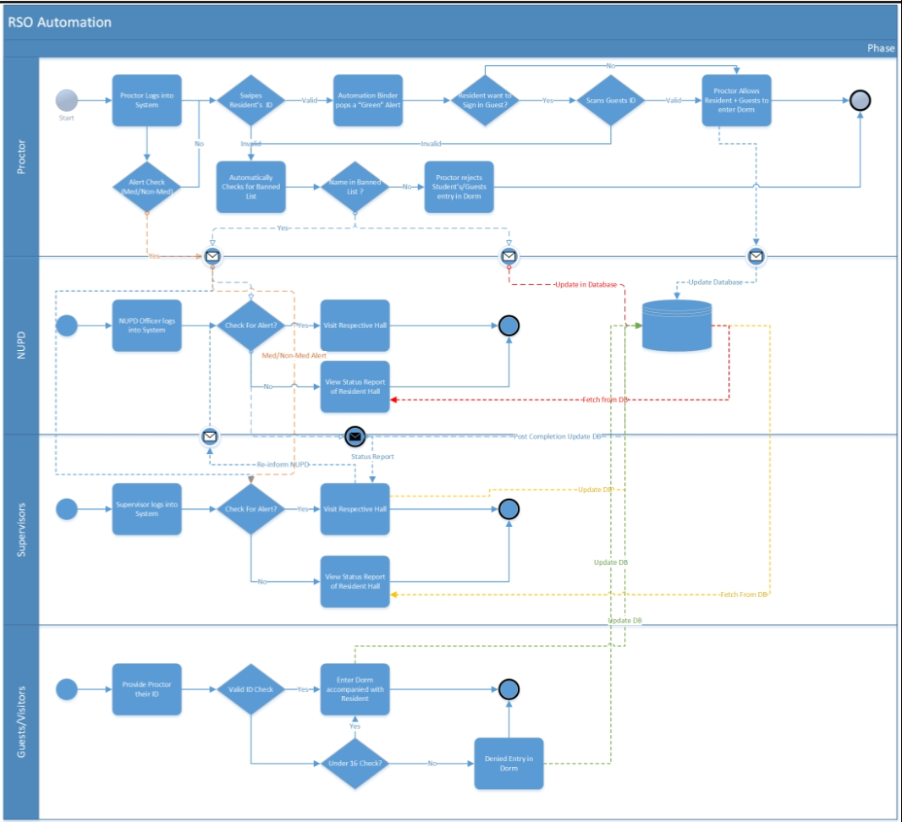

## 3.4 User Personas

|  |
| --- |
|  |
|  |
|  |
|  |

# 4. Use Cases

The various user classes identified the following primary actors and use cases for the Automation Binding System:

|  |  |
| --- | --- |
| Primary Actor | Use Cases |
| Proctor | 1. Login to System 2. Swipe Students NUID 3. Swipe Guest ID 4. Checked Banned List alerts 5. Contact NUPD in case of emergency |
| Resident | 1. Provide a valid NUID 2. Provide the Number of guests |
| Non-Resident(Guest) | 1. Provide a valid Photo ID |
| NUPD | 1. Monitor Alerts 2. Medical Alerts 3. Non- medical Alerts 4. Banned List Alert |
| RSO Supervisor | 1. Login to the system 2. Monitor Alerts 3. Medical Alerts 4. Non- medical Alerts 5. Banned List Alert 6. Check database for previous records |

|  |  |  |  |
| --- | --- | --- | --- |
| ID and Name: | UC-1 Login to the system | | |
| Created By: | Team Automation Binder | Date Created: | 11/01/16 |
| Primary Actor: | Proctor | Secondary Actors: | Automation Binder |
| Description: | A Proctor will access the proposed system from the RSO station through the tablet provided, he can swipe in residents and guests, manage the alerts and contact NUPD in case of emergency. | | |
| Trigger: | A resident/guest wants to enter a building | | |
| Preconditions: | PRE-1. Proctor has valid credentials.  PRE-2. Proctor is scheduled for the shift. | | |
| Postconditions: | POST-1. Resident/Guest enters the building after system validation.  POST-2. Each entry (resident/guest) is stored in the database. | | |
| Normal Flow: | 1.0 Swipe in the resident   1. Resident provides his NUID. (see 1.0.E1, 1.0.E2) 2. Proctor Swipes the ID card. (see 1.0.E1, 1.0.E2) 3. System will validate if the student resides in the building 4. System notifies the proctor with a green light and a pop up with the details if the student is a valid resident 5. Student is given access to enter the building 6. System notifies the proctor with a red light and a pop up with the details if the student is not a resident 7. Nonresident is not given access to enter | | |
| Alternative Flows: | 1.1 Resident wants to sign in a single guest  Follow steps 1.0.1 and 1.0.2 above.  Select the option to sign in a guest.  Proctor swipes in Guests ID  System will validate whether the guest is not in the banned list  Return to step 5 of normal flow.  1.2 Resident wants to sign in multiple guest  Resident asks proctor to enter another guest.  Return to step 2 of alternate flow. | | |
| Exceptions: | 1.0. E1 Students NUID is not detected in the system  1. Proctor checks the students resident list manually and calls supervisor  2. Supervisor will escort the resident to enter the building.  1.0. E2 Guest ID does not have a barcode reader  1. Proctor will manually enter guest details in the tablet after verifying the ID and checking the banned list | | |
| Priority: | High | | |
| Frequency of Use: | Approximately 10,000 residents, average of 1000 users per hours. Peak usage load for this use case is between 6PM to 11PM. | | |
| Other Information: | During weekdays, a student can sign-in up to 3 guests.  During weekends a student can sign-in up to 5 guests.  Residents and guests should provide a valid photo ID | | |
| Assumptions: | Assume that 40 percent of Residents will sign in their guests daily (source: RSO Proctors and Supervisor). | | |

|  |  |  |  |
| --- | --- | --- | --- |
| ID and Name: | UC-9 Monitoring Alerts | | |
| Created By: | Team Automation Binder | Date Created: | 11/01/16 |
| Primary Actor: | NUPD | Secondary Actors: | Automation Binder |
| Description: | NUPD plays a major role in providing security for the welfare of residents as well as guests. The NUPD will take care of all the emergency issues faced on campus housing. The emergency issues include medical, non-medical and banned list alerts | | |
| Trigger: | A resident/guest faces an emergency situation on campus  A person from banned list tries to enter the residence  Any threats faced by a proctor during his/her duty | | |
| Preconditions: | PRE-1. Student proctor should send an alert through SOS feature in the application for alerting NUPD in case of medical and non-medical emergencies | | |
| Postconditions: | POST-2. The NUPD will visit the concerned location and solve the problem as soon as they get the alert | | |
| Normal Flow: | 5.0 Monitor Alert  The proposed system notifies NUPD based on Medical, Non-Medical and Banned List Alert  Medical Alert  1. NUPD officer checks the state of the student if he is a resident and escorts him to the room  2. NUPD takes necessary medical steps depending on the severity of case  Non – Medical Alert  1. NUPD officer escorts the drunk student if he is a resident to the room  2. NUPD takes necessary steps if the proctor was threatened  5.0.3 Banned List Alert  1. NUPD officer enquires the proctor about the banned person’s whereabouts  2. NUPD does not allow the banned person to enter the resident hall | | |
| Alternative Flows: | None | | |
| Exceptions: | 5.0.E1 The person trying to enter is not a resident  1. Proctor informs NUPD and RSO supervisor through the SOS option in the application | | |
| Priority: | High | | |
| Business Rules: | BR-86 and BR-88 | | |
| Other Information: | Expect high frequency of executing this use case within first 2 weeks after system is released. | | |

# 5. User Interface Displays

## 5.1. Login Screen

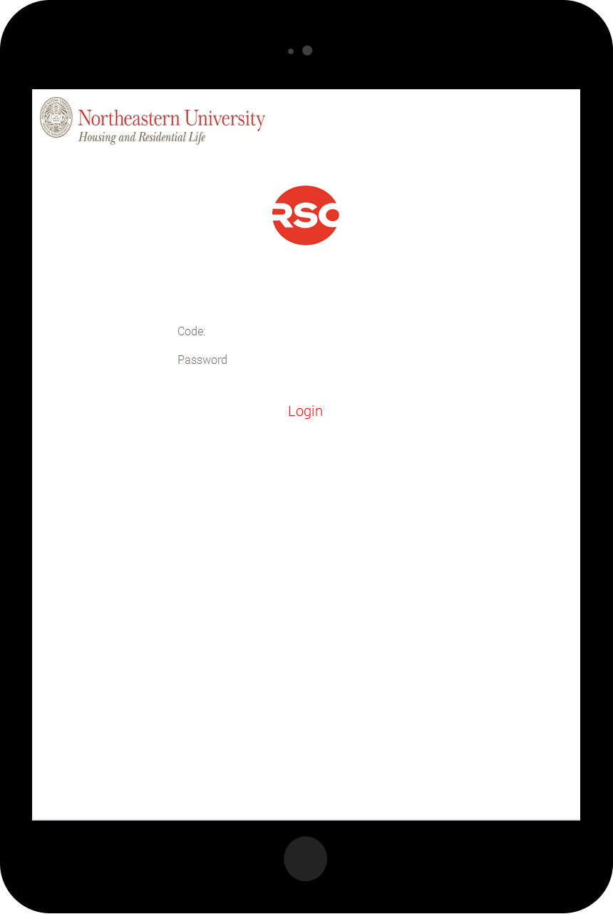

## 5.2 Proctor Home Page

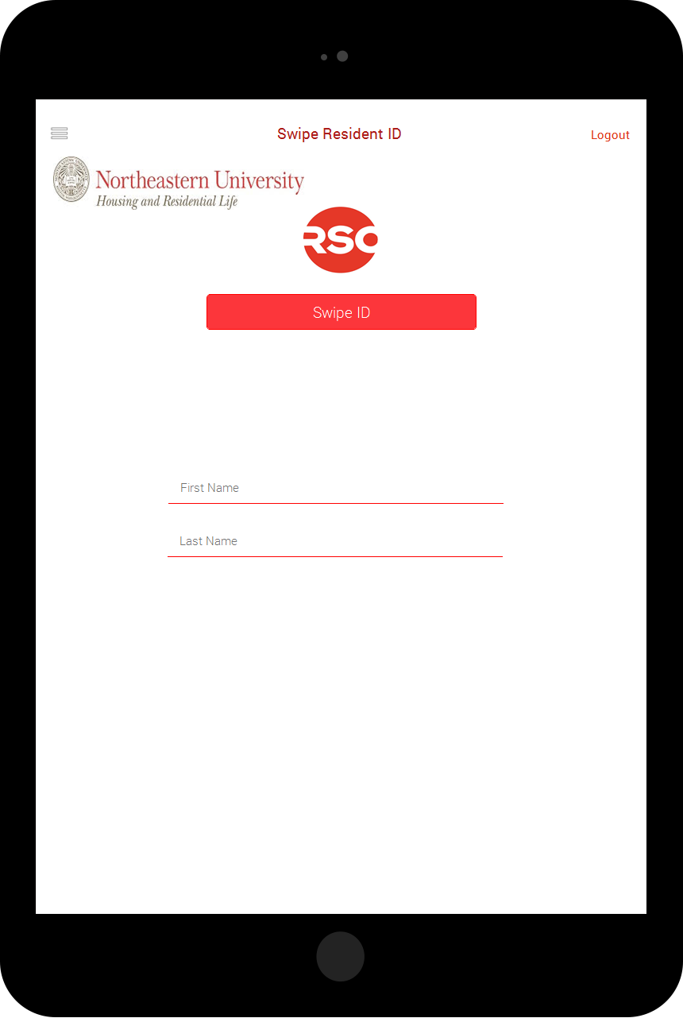

## 5.3 Swipe Resident

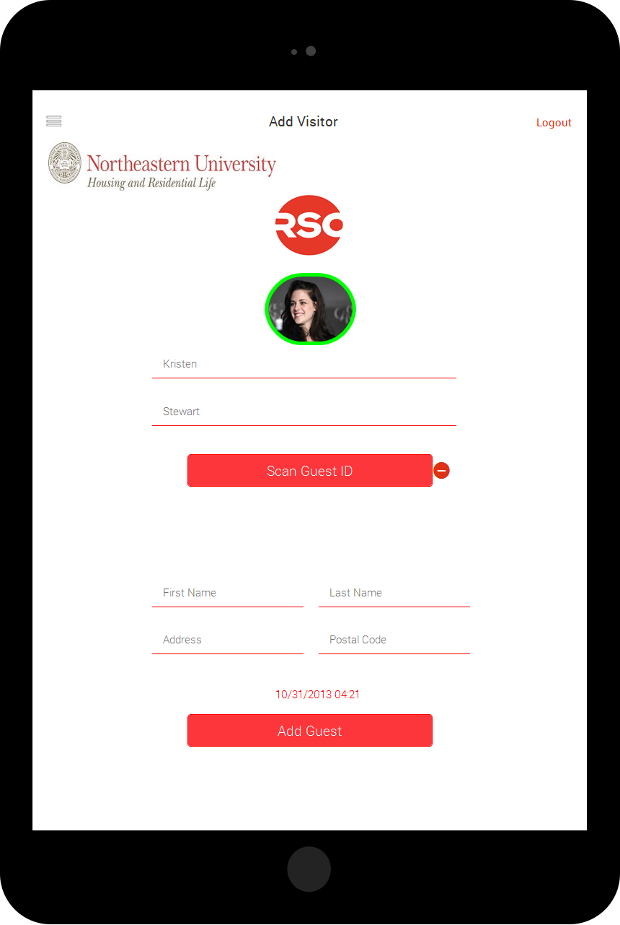

## 5.4 Valid Guest

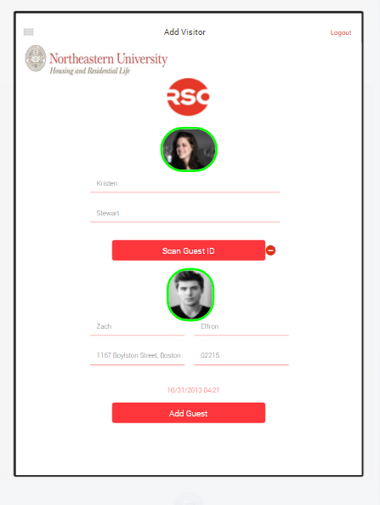

## 5.5 Banned Guest

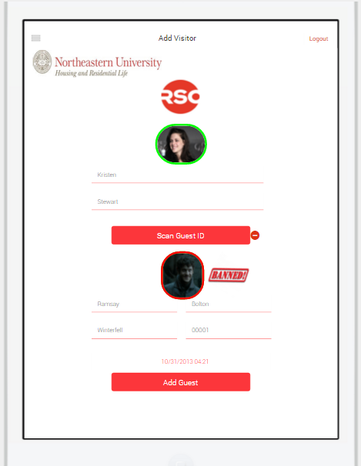

## 5.6 Live Chat with Supervisor

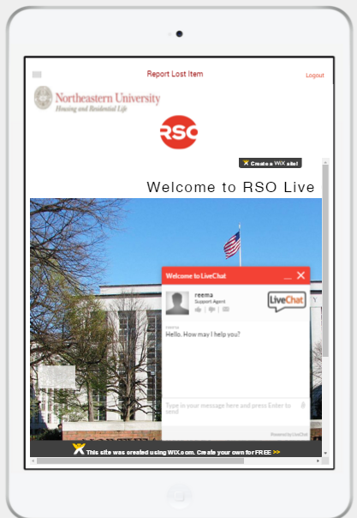

## 5.7 Side Panel for Proctor

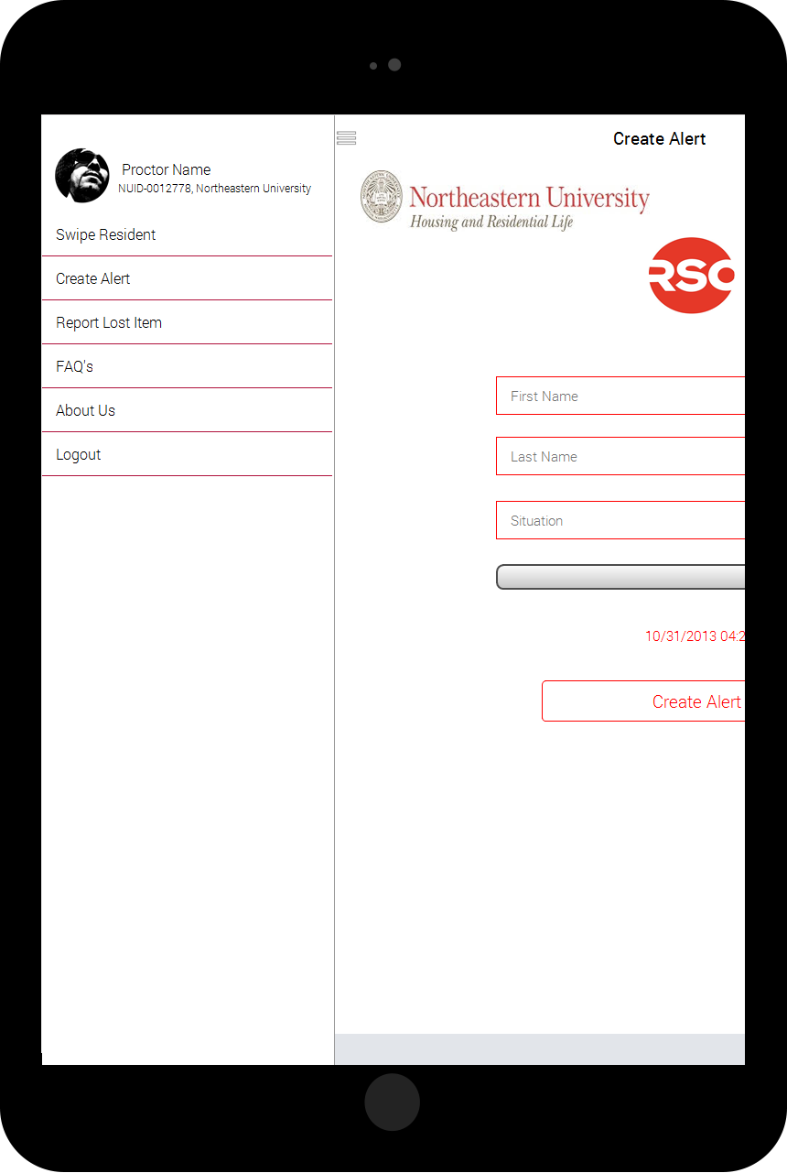

## 5.8 Supervisor Home Page

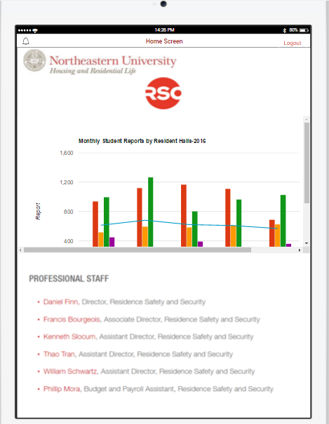

## 5.9 Supervisor Banned List alerts

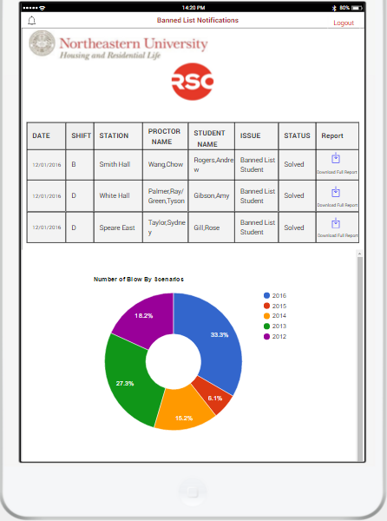

## 5.10 Medical Alerts Supervisor

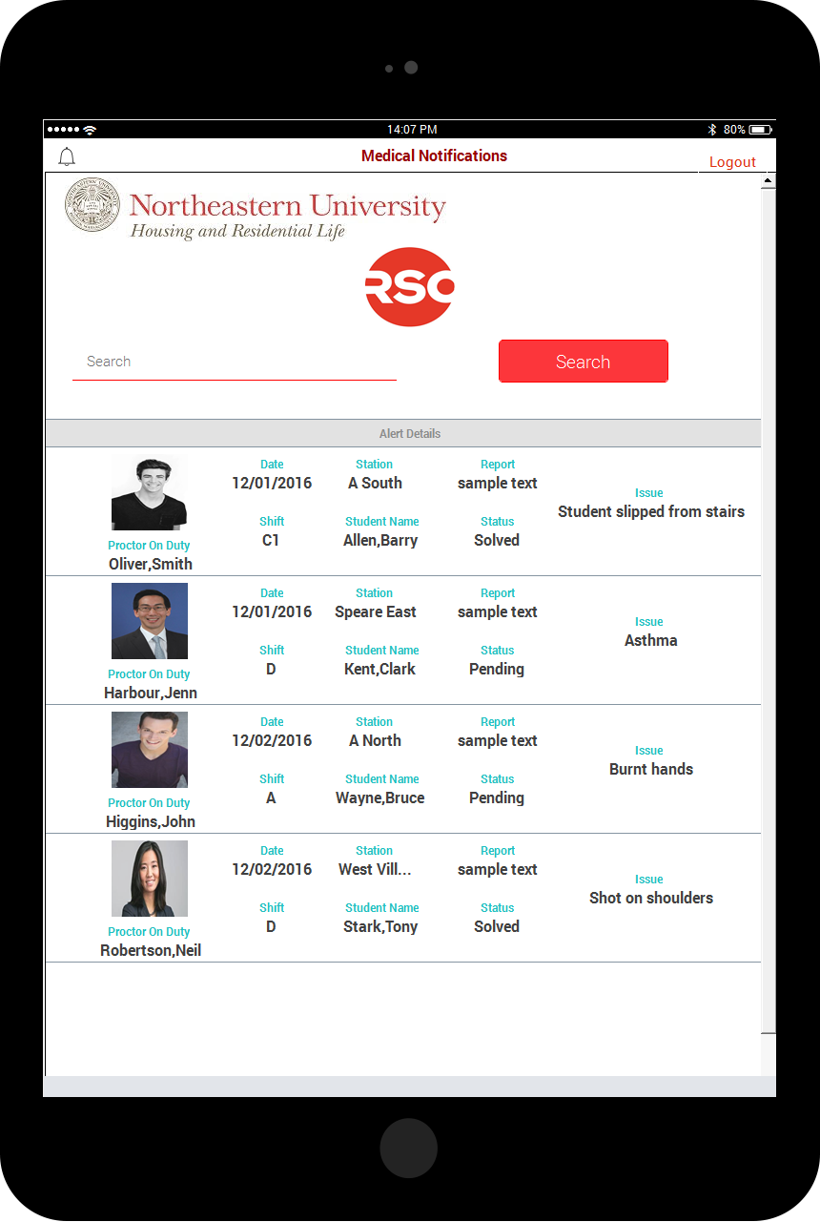

## 5.11 Supervisor Side Panel

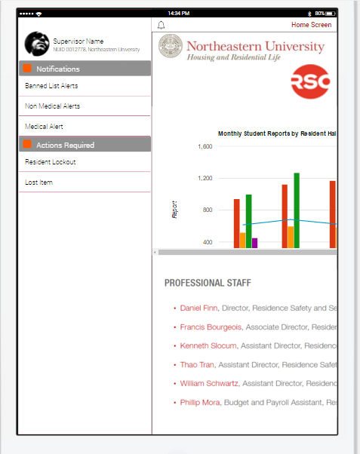

## 5.12 NUPD Home Page

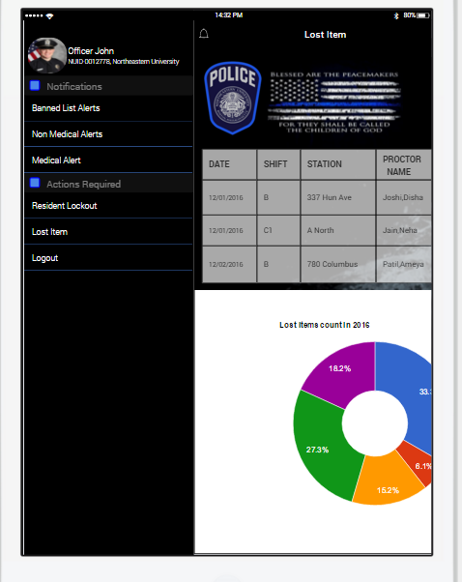

## 5.13 NUPD Lost Items

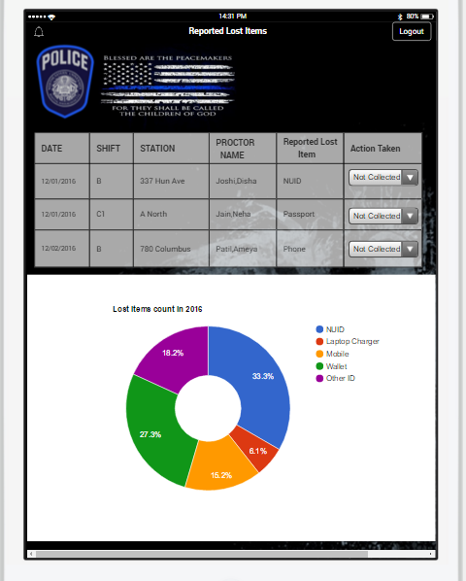

## 5.14 NUPD Medical Alerts

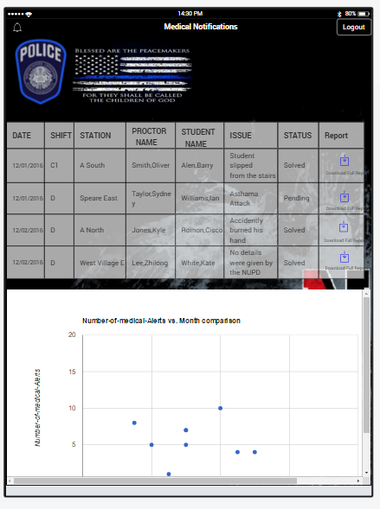

## 5.15 NUPD Non Medical Alerts

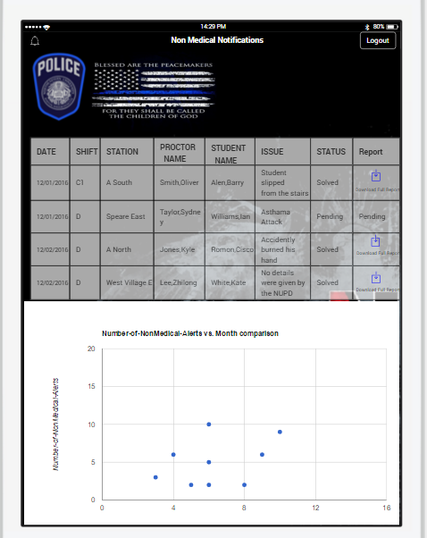

## 5.16 NUPD Banned List Alerts

